**Hunmanby Primary School Year 3 Curriculum Newsletter**

**Spring Term**

Dear Parents/ Carers

Please find below an overview of how busy we are going to be…



**Rocks, Relics and Rumbles**

**Rocks, Relics and Rumbles** is the title of our topic this term and is driven by Geography objectives. It teaches children about the features and characteristics of the Earth's layers, including a detailed exploration of volcanic, tectonic and seismic activity.

**Literacy**

The children have been working hard on their writing last term and we will continue with *‘The Write Stuff’* to support further progress. We will start the year exploring the narrative tragedy ***Flood* by Alvaro F. Villa**. An explanation text on ***How a Robot Dog Works***will be next before we explore second non chronological report about **Earthquakes** which will link well to our topic.

**Maths**

We begin 2025 with **multiplication and division** where we will learn formal written methods to multiply and divide. Our second unit of work is **length and perimeter** and we will compare and explore equivalent lengths. After this, we will look at **fractions** where our times table facts will be vital to our success and before finally moving on to mass and capacity.

Lessons will follow the same structure as the Autumn term. Children are always given the opportunity to apply their knowledge and develop their reasoning skills. A range of manipulatives are always available to support working.

We will begin **weekly times table tests** this term. **Times Tables Rock Stars** is a carefully sequenced programme of times tables practice which successfully boosts times tables recall speed. Any additional time spent on the programme at home will greatly support progress in school.

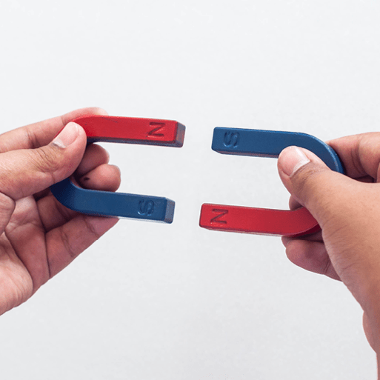**Science**

Our topic this term is **Forces and Magnets.** This project teaches children about contact and non-contact forces, including friction and magnetism. They investigate frictional and magnetic forces, and identify parts of a magnet and magnetic materials.

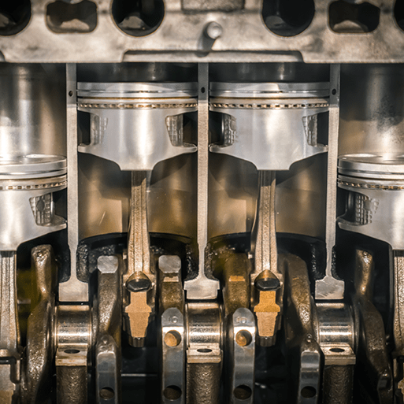**D&T – Making It Move**

Children will learn about cam mechanisms. They will experiment with different shaped cams before designing, making and evaluating a child's automaton toy. I know from the creativity I saw in the autumn term that these will be great!

**Art and Design**

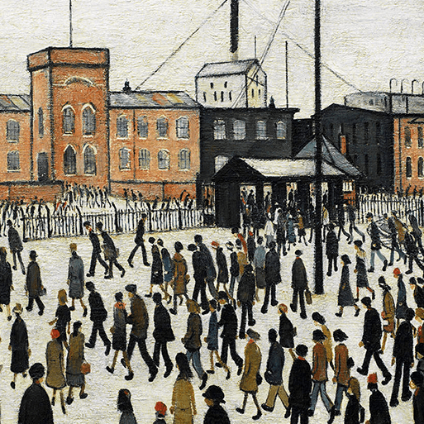We will cover two art and design topics this term. The first is **People and Places** which teaches children about the genre of figure drawing. They will explore the figure drawings and urban landscapes of the artist LS Lowry and create artwork in his style to show scenes from our classroom and areas around school. Our second topic will be **Ammonite** where the children will be taught about artistic techniques used in sketching, printmaking and sculpture.

**PSHE**

***Citizenship*** will be our first focus in PSHE and will be taught by Mrs Milnes. The children will learn about children’s rights; exploring why we have rules and the roles of local community groups, charities and recycling and will have an introduction to local democracy. After the half term break we will move on to ***Economic wellbeing*** and look at budgeting, learning about the different paying methods, the emotional impact of money, the ethics of spending, potential jobs and careers and learning that anyone can aspire to anything.

**Music**

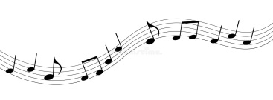Last term, we were lucky to have our music lessons with Mr Chatto. The children made incredible progress and performed with control and confidence to an audience in school.

We will now complete the music unit, ‘Let Your Spirit Fly’. We will enjoy R&B, Western Classical, Musicals, Motown and Soul before moving on to ‘Glockenspiel Stage 1’ where we will learn basic instrumental skills by playing tunes in varying styles.

**Computing**

This term we will use *Scratch* to explore programming. The children will be introduced to a selection of motion, sound and event blocks which they will use to create their own programs. We will then move on to explore branching databases. Learners will develop their understanding of what a branching database is and how to create one. They will use yes/no questions to gain an understanding of what attributes are and how to use them to sort groups of objects.

**PE**

PE will Tuesday afternoon, but we will have sports coaches in until the end of Term 3. Children should have their PE kits in school (white t shirt and black shorts or jogging bottoms) including clothes for outside PE. We will be focusing on **Invasion games** and **Dodgeball** this term.

**PPA time**

My planning afternoon is on a Tuesday and so therefore I will not be in class. The children will be taught by Mrs Milnes who, for the Spring term, will teach the children PSHE and PE.

**Homework**

The children will receive homework **every Friday** which must be handed in by the following **Thursday.** They will receive either one piece of maths, literacy or a topic based task every week.

As part of homework this year, the children will get spellings. They will be sent home on a Friday and assessed the following Friday. We ask that you sign the spelling book in acknowledgement of seeing/helping them practise.

Children are also expected to use Times Table Rock Stars, to help boost their fluency. We will be doing regular in class checks to monitor progress.

**Reading at home**

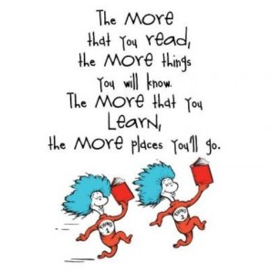We were delighted with the amount of children who read at home at least 3 times a week last term with many of you going above and beyond this minimum expectation! Thank you for your support with this.

Reading to your child is just as important as them reading to you and really helps to build a true love of reading. It is always wonderful to hear children discuss what they are reading for pleasure and share reading experiences from home.

Children will continue to select a reading for pleasure book each Friday. Just a reminder that I would like the books in school every Friday where they can be swapped or the children can opt to keep until they have finished.

**Class Dojo**

Look out for regular updates of how busy we are and our fantastic work on your Class Dojo app.

Dojo is our main reward system; we will continue to award Bronze, Silver and Gold certificates as Dojo points build and some children may even reach platinum by the end of the year.

**TA support**

Mrs Jackson will continue to support Year 3 each morning and Mrs Flett will support on Wednesday and Thursday afternoons.

If you have any questions or queries please do catch me on the playground before or after school where I will be more than happy to speak. Alternatively, message me using the Dojo app.

Many thanks in advance for your support in the term ahead!

**Miss Pratt** - Year 3 Class Teacher